**Module 5 Lesson 1**

**Introduction to Probability**

**Two-Way Tables, Venn Diagrams**



Learning Targets

I can define probability and use the definition in chance experiments.

I can find the sample space for a chance experiment.

I can determine the probability of the union or intersection of two events.

Basic Definition of Probability:

ALL PROBABILITIES LIE BETWEEN $0≤P(E)≤1$

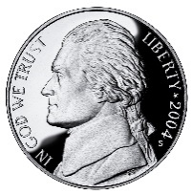

**Probability of Landing on heads from flipping a coin:**

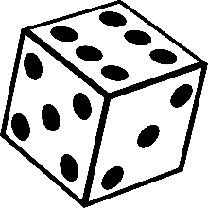**Probability of an odd # rolling a 6 sided die:**

**Theoretical Probability vs. Empirical Probability**

***Theoretical probability***: we don’t actually have to run the experiment to determine the probability of an event.

***Empirical probability***: odds from running the experiment.

We flip a coin 4 times…what is the Theoretical probability of coin landing on heads on the next flip?

We flip a coin 4 times (lands: H, T, H, H)…what is the Empirical probability of coin landing on heads on the next flip?

|  |  |
| --- | --- |
| Soda | Number who preferred |
| A | 18 |
| B | 24 |
| C | 11 |
| Total | 53 |

**Example:** A survey was done by a marketing company to determine which of three sodas was preferred by people in a blind taste test. The results are shown.

Find the empirical probability that a person selected at random from this group would prefer soda B. Express your answer as a fraction and as a decimal accurate to two decimal places

Find the empirical probability that a person selected at random from this group would not prefer soda A. Again, express your answer as a fraction and as a decimal accurate to two decimal places.

**Complement (Not)-**

**Example:** If the probability that it will rain tomorrow is 20%, what is the probability that it will not rain?**Symbols in Probability**

$$P(A)$$

$$P(A∩B)$$

**Name:**

**Explanation/Formula:**

$$P(A∪B)$$

**Name:**

**Explanation/Formula:**

**\*\*\*\*\* P(A U B) =**

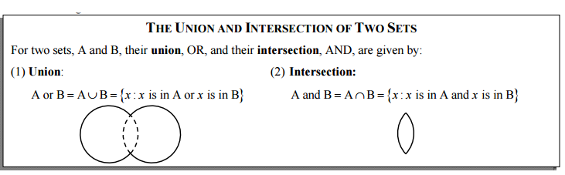

**Example:** Consider the spinner shown below that has been divided into eight equally sized sectors of a circle. The spinner is spun once.

Let A = event of the spinner landing on an even number

Let B = event of the spinner landing on a prime number.

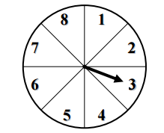 $P(A) =$

$$P(B) =$$

$$P(A∩B) =$$

$$P(A∪B) =$$

HOMEWORK:

**Example:** A small high school surveyed 52 of its seniors about their plans after they graduate. They found the following data and wanted to analyze it based on gender. In this case, if we pick a student at random, we can place them into one of four events:

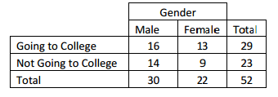

M = Male

F = Female

C = Going to College

N = Not going to college

Find each of the following probabilities:

1. P(M) d) P(F) g) P(C)

1. P(N) e) $P(M∩C)$ h) $P(F∩C)$
2. $P(F∪C)$ f) $P(M∪N)$

**Example:** A standard six- sided die is rolled once. Find

$$P(even or a multiple of 3) =$$

$$P(even and a multiple of 3) =$$

$$P(prime or greater than 5) =$$

$$P(prime and even) =$$

**Example:** Insurance companies typically try to sell many different policies to the same customers. At one such company, 56% of all the customers have car insurance policies, 48% have home insurance, and 18% have both. A customer is picked at random.

1. Find the probability that she or he has at least one of the policies.
2. Find the probability that she or he has neither of the policies.